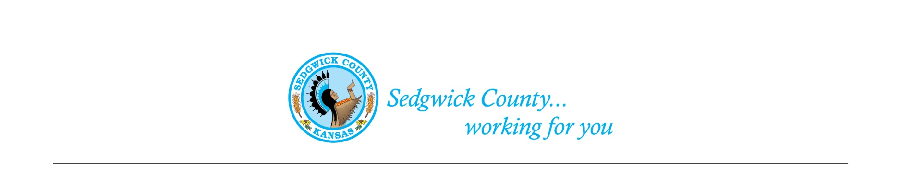
Sedgwick County Animal Care Advisory Board Meeting
Animal Control
Sedgwick County Health Department
1015 Stillwell, Wichita, KS 67213 - www.sedgwickcounty.org - TEL: 316-660-7078 - FAX: 316-383-7553
Nika Orebaugh, Animal Control Supervisor
Program Supervisor
Of December 9, 2021
Attendance:
Advisory Board
Members- Susan Erlenwein, Simone Ward, Shelley Seidl, and Dr. Julie Evans. Members attended in person, and by Zoom.
Absent- Laura Adkins, Patricia Miller, Debbie Miller and Shanti Leiker
Public- None
Sedgwick County Staff- Nika Orebaugh
1. Old Business:
A. Minutes: Discussion and approval of September 9, 2021 minutes. Moved and second by Shelley Seidl and Simone Ward. Approved by majority vote.

2. New Business:
A. Review of Dog Breeding Regulation – Susan Erlenwein reviewed the changes recommended by Kirk Sponsel, Assistant County Counselor. The Board discussed and approved the changes. Susan will update the draft dog breeding regulations and forward them to Kirk.

B. ARPA: - Simone Ward requested an off-agenda item to discuss an upcoming ARPA application deadline. The Board agreed to discuss this issue due to a deadline timing issue. Sedgwick County has received over $100 million in ARPA funds. There is a form (Letter of Interest) that can be filled out online for businesses, organizations, governments and others to request funds for Covid-related expenses. The Board discussed the problems that Animal Control and others have seen due to Covid-19. This includes a 40% increase in pets being abandoned as a side-effect due to Covid. Pets were adopted when people stayed at home and were abandoned due to financial problems or when many returned to work. The rescue groups and shelters have reached capacity overflow. The Board agreed to fill out a Letter of Interest to build a Sedgwick County Animal Shelter and Adoption Center. The goal will be the adoption of pets and to work with shelters and rescue groups to achieve this goal. Susan, Simone and Nika will work on the submittal of a Letter of Intent.

C. Exotic Animal Regulations – This issue will be addressed at the next meeting.
D. Staff Update- Nika had no updates due to meeting time constraints.

4. Public –None

5. Adjournment – The Board agreed to adjourn at 8:00 PM.

