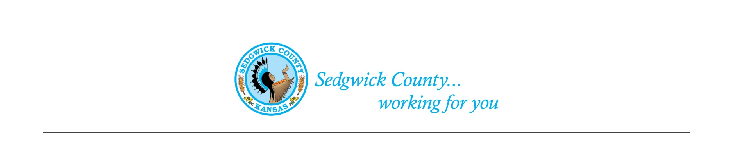
Sedgwick County Animal Care Advisory Board Meeting
Animal Control
Sedgwick County Health Department
1015 Stillwell, Wichita, KS 67213 - www.sedgwickcounty.org - TEL: 316-660-7078 - FAX: 316-383-7553
Nika Orebaugh, Animal Control Supervisor
Program Supervisor
Of April 13, 2023
Attendance:
Advisory Board
Members - Susan Erlenwein, Simone Ward, Shelley Duncan, Janna Hays, Debbie Miller, and Dr. Julie Evans
Absent - Shanti Mikolajczyk and Patricia Miller
Public - Linda Leatherman, Randy Hazen and Heath Hazen
Sedgwick County Staff - Nika Orebaugh, Dina Ingram, and Dakota Kidd
1. New Business: Due to guests who wanted to address the Board, Susan moved New Business to the start of the meeting to allow the guests to leave prior to Old Business if they wished to do so.
A. Susan had prepared comparison tables pertaining to problem pet owners. These tables compared definitions of owners, definitions of violations, definitions of infractions, pets involved, violations, determination of problem owners, actions against owners, relinquish of pets, and penalties. The Communities reviewed were Tacoma, Washington; South Bend, Indiana; Fort Wayne, Indiana; Pierce County, Washington; Sedgwick County, Kansas; and Wichita, Kansas. The tables had been emailed to the Board members and the public present at the March meeting prior to tonight’s meeting. Susan reviewed each section and the Board discussed and agreed upon the wording to include in the Sedgwick County Code pertaining to Habitual Animal Violators. Susan agreed to compile these comments for review at our May meeting. She will also forward them to the Legal Department for review. A discussion was held on why the current County regulations do not allow Animal Control Officers to pick up animals under certain circumstances. There was also a discussion on the trapping of animals and what is and is not allowed. Nika will ask the Legal Department if she can loan out County traps.

B. Other New Business: There was no other new business to come before the Board.

2. Old Business:
A. Minutes: Discussion and approval of March 9, 2023 minutes. Moved and seconded by Simone Ward and Shelley Duncan. Approved by majority vote.
B. Proposed Sedgwick County Animal Shelter: Due to time limitations, a short discussion was held on potential funding options for a new shelter.
3. Staff Update- Nika reviewed some of their upcoming events in Oaklawn. These include vaccine clinics, microchips, spay & neuter clinic, and a Pet Fair Day.
4. Public –Thanked the Board for looking into changing current regulations pertaining to owners of habitual animal violations.
5. Adjournment – The Board agreed to adjourn at 8:09 PM.

