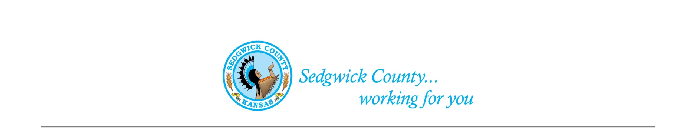
Sedgwick County Animal Care Advisory Board Meeting
Animal Control
Sedgwick County Health Department
1015 Stillwell, Wichita, KS 67213 - www.sedgwickcounty.org - TEL: 316-660-7078 - FAX: 316-383-7553
Nika Orebaugh, Animal Control Supervisor
Program Supervisor
Of April 11, 2024
Attendance:
Advisory Board: Members Present - Susan Erlenwein, Simone Ward, Janna Hays, Dr. Julie Evans, Shelley Duncan, Susan Lentz, and Erika Lovett
Members Absent –Kylee Wallentine and Shanti Mikolajczyk
Public – None
Sedgwick County Staff –Nika Orebaugh, Chris Stewart and Dina Ingram
1. New Business:
A. Minutes: Discussion and approval of March 14, 2024 minutes. Approval of the minutes was moved by Simone Ward and seconded by Janna Hays. Motion was approved by majority vote.
C. Report on KDA developments and how they will affect Sedgwick County operations: Nika Orebaugh brought the Board up-to-date on recent developments in the Kansas Department of Agriculture (KDA). There has been discussion on regulatory changes. There is talk of a letter on this issue from a local veterinarian coalition against this. There are already laws in place protecting veterinarians and not to question their decisions.

2. Old Business:
A. Sedgwick County Animal Control Programs: Susan Erlenwein reviewed statements in our ACAB Bylaws that note we are to guide the Animal Control Department in all phases of its operation. We are also to determine operational policies and procedures. We have been working on various code upgrades to improve their ability to serve the public and protect animals. Susan will check with the Legal Department to determine the status of those codes changes and next steps we need to take to get them approved by the County Commissioners.
3. Staff Update- Nika reviewed some upcoming events, including an Outreach Fair for the homeless. She mentioned a staff shortage right now due to health issues. She also mentioned school presentations are not back up to the level as it was before COVID.
4. Public – None
5. Adjournment – The Board agreed to adjourn at 7:05PM.

