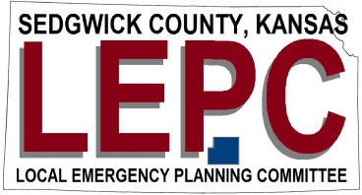

Meeting Locations 2021

February 18th 2pm
https://us02web.zoom.us/j/87204847573
Dial by your location: 1-346-248-7799
Meeting ID: 872 0484 7573
** Presenter Chance Hayes NOAA

May 20th 2pm
https://us02web.zoom.us/j/85220847489
Dial by your location: 1-346-248- 7799
Meeting ID: 852 2084 7489
**Presenter Matt Vogt Valley Center Police Department

August 19th 2pm
https://us02web.zoom.us/j/84573049312
Dial by your location: 1-346-248-7799
Meeting ID: 845 7304 9312
**Presenter David Byers Ardent Mills

November 18th 2pm
https://us02web.zoom.us/j/86938365579
Dial by your location: 1-346-248-7799
Meeting ID: 869 3836 5579
**Presenter Daniel Fenn c3Safety

