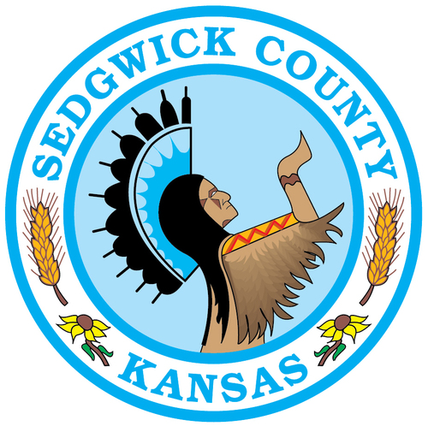

**Sedgwick County, Kansas**

**2021 Federal Agenda**

**

Table of Contents

Northwest Wichita Bypass p. 1

Amtrak Extension p. 3

Dry Creek Overflow Detention Facility p. 4

Health and Social Services p. 5

Federal Funding for County Services p. 6

**Northwest Wichita Bypass**

**SUPPORT** funding for the Northwest Wichita Bypass (KDOT Project Numbers 254-87 K-8234-03, 254-87 K-8234-04, and 54-87 K-8235-02).

* This project entails the construction of a new access controlled highway from US-54 at the City of Goddard to K-96 between Tyler Road and Ridge Road at the City of Maize. It includes the Dry Creek detention basin near 13th St. North and 167th St. West. It would extend the interstate level highway system at Maize to west Wichita and Goddard.
* US-54 through west Wichita will continue to see increasing levels of passenger and freight traffic moving from the I-135 corridor out of northeastern Kansas (Kansas City Metro) into western Kansas and points down into New Mexico. Urbanization in far northwest Wichita, Goddard and Maize will continue to drive demand for efficient movement of workers to employment centers in around Wichita. There are space and design limitations in the US-54 corridor that will require development of this alternative route to manage overall congestion in the community as it develops over time. Construction of the Dry Creek detention basin will mitigate flooding on Dry Creek, Calfskin Creek and Cowskin Creek in northwest Wichita providing protection for many existing homes and businesses.
* A study began in 1997 with public involvement efforts to select a preferred design alternative between 2001 and 2005. The preferred alternative was selected and the Environmental Impact Study with federal concurrence on the Finding of No Significant Impact (FONSI) completed in 2006.
* The NW Wichita Bypass projects are right-of-way (ROW) preservation projects. The intent is for KDOT to pursue ROW acquisitions, in coordination with KDOT’s local partners, in those areas within the overlay corridor with high development potential and/or acquisitions for rare cases where landowners are experiencing hardship and uncertainty beyond that inherent for all property owners along the project corridor.
* Project Status
  + Design: 60% complete (preliminary design with Plans to ROW completed in 2006); Right-of-Way Preservation Funding Agreements are in place. No funding identified or obligated for final design at this time.
  + Right of Way: Total to be Acquired is 1,334 Acres at a cost of $50 million. To date, 356 acres (26.7%) of right of way needed for project (additional 114 acres acquired is considered excess ROW such as uneconomic remnants. Thus far, $19.7 million has been expended and another $30.3 is needed.
  + Corridor Protection: Sedgwick County and the City of Wichita established a protective overlay in the zoning code in 2007 that protects right of way in the proposed route by providing notice that development is about to occur. That notice triggers an analysis by KDOT to determine if immediate steps should be taken to acquire the right of way.
  + Funding Sources: KDOT, Sedgwick County, Wichita, Goddard and Maize have participated in three partnership agreements beginning in 2006 to provide funding to purchase right of way for the project. The current 5 year agreement between KDOT, Sedgwick County, Goddard and Maize expired in 2020 and the parties are currently working on a new agreement.
  + Environmental Clearance was received in 2006.
  + Construction Cost Estimate: $519.2 million. No funds identified or obligated for final design or construction at this time. We are considering phased construction and tolling options.

**Amtrak Extension**

**SUPPORT** the extension of Amtrak service from Oklahoma City, Oklahoma into Newton, Kansas.

* The Heartland Flyer connects Oklahoma City, OK to Fort Worth, TX. At Fort Worth, connections are available to Dallas, Chicago and San Antonio via the Texas Eagle. As seen on the map below, a 200 mile service gap exist between Oklahoma City, serviced by the Heartland Flyer, and Newton, serviced by the Southwest Chief, which runs from Chicago, IL to Los Angeles, CA.
* Amtrak has expressed support for extending the Heartland Flyer north, known as the Northern Flyer, through Wichita and on to Newton to connect these two major routes. Ridership along this corridor is expected to be high enough to make this “a very successful train”, according to Michael Franke, Assistant Vice President for Policy and Development, for Amtrak (Press Conference, Topeka, KS, March 2010).
* Home to several million people, the proposed passenger rail corridor from Oklahoma City to Newton would in effect connect the economic, manufacturing and transportation centers along the I-35 Corridor Megaregion (Central Plains) with the shipping centers in Chicago and energy production centers in Texas. Through strengthened connections a more prosperous economy will develop from Chicago to San Antonio**.**
* Amtrak, BSNF and KDOT have conducted a study to determine the infrastructure costs, which are $124.4 million: $31.2 million for Kansas rail improvements and $93.2 million for Oklahoma rail improvements. These costs include:
  + $28.8M (across both states) for upgrades necessary for 79mph operating speed
  + $15.8M for an extension of a siding on the Arkansas City, BNSF Kansas subdivision rail (2.3 miles)
  + $79.8M for an extension of a siding near Oklahoma City (4 miles – includes 5 bridges)

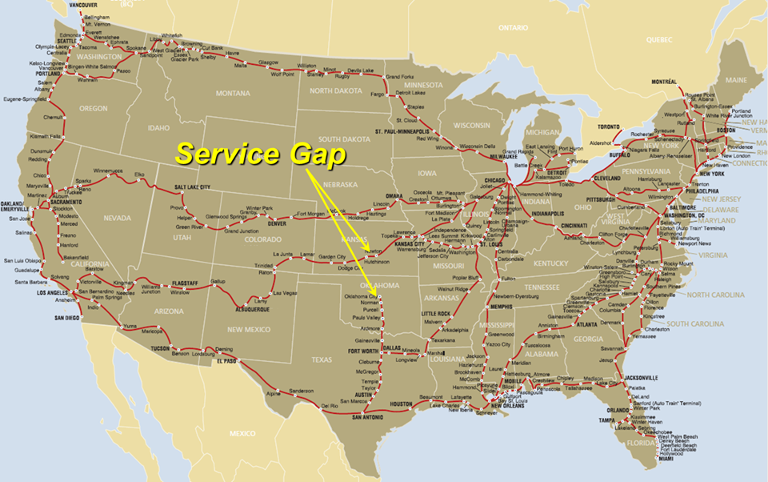Next steps for KDOT include:

* Working with Oklahoma because infrastructure improvements will be required within their state borders.
* Partnering with Amtrak and stakeholders, including communities and agencies to update the Service Development Plan that will guide future implementation of the service.
* Obtaining funding for Amtrak start-up costs along with the infrastructure investment that BNSF requires, and the annual operating cost.
* Working with communities that have stops in the updated Service Development Plan. Communities will need to commit to investing in station stops and necessary investment for the service.
* BNSF will need to complete the second phase of the infrastructure needs assessment that focuses on a future growth scenario to provide final cost estimates necessary for future implementation of the service. This will only happen when a commitment of state or local funding is made to establish the Heartland Flyer service on the corridor.
* By closing the 200 mile Service Gap, KDOT, ODOT and the City of Wichita are partnering to improve the region’s manufacturing base, worker productivity, commerce, trade, connectivity and economic mobility, and reconnect the significant rural areas to the region’s metropolitan centers.

**Dry Creek Overflow Detention Facility**

**SUPPORT** funding for a U.S. Army Corps of Engineers Feasibility Study, under Continuing Authorities Program (CAP) Sec. 205 Flood Damage Reduction, for the Dry Creek Overflow Detention Facility. The County will submit a letter to the District Engineer requesting their assistance in determining if there is a Federal interest.

* The Dry Creek Overflow Detention facility project came about because of flooding that occurred in 1998 between November 1st and 2nd, in west Wichita. This event is known as the Halloween Flood, causing damage to over 100 homes and businesses that were constructed after the adoption of the first Federal Emergency Management Agency (FEMA) Flood Insurance Rate Maps (FIRM) in 1986.
* Unfortunately, the 1986 FIRMs did not properly identify the flooding risks because the models that established the affected flood hazard boundaries for the Calfskin Creek and its tributaries did not include the transfer of runoff between Dry Creek of Cowskin Creek and the Northfork Calfskin Creek tributaries. The diversion of runoff between these watersheds was not known because the topography used to complete the modeling was based on United States Geological Survey (USGS) mapping using 5 foot contour intervals.
* 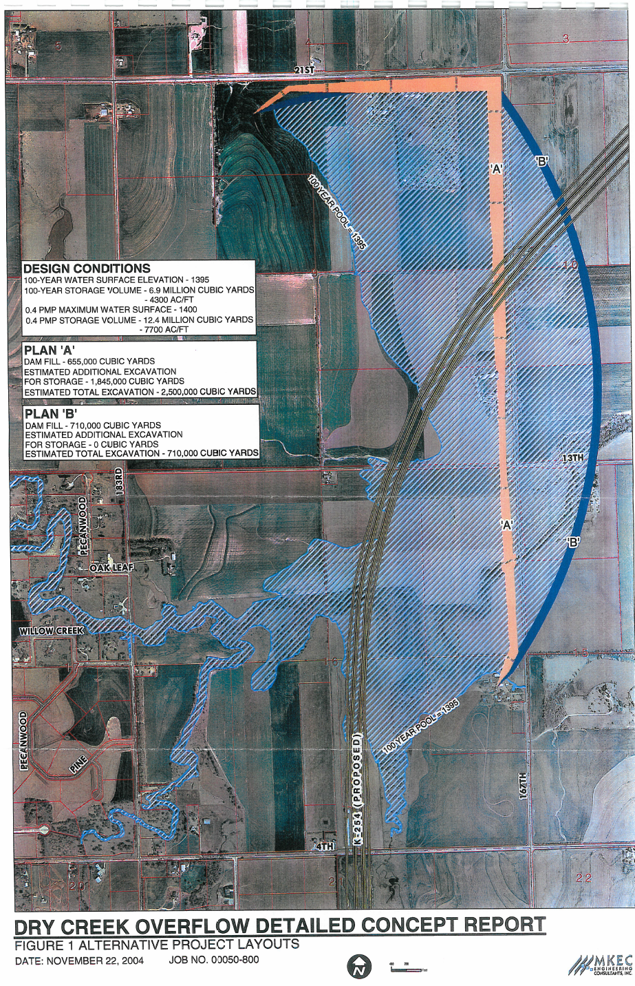By March 2003, the Cowskin Creek Basin Stormwater Master Drainage Plan identified a potential site for a Dry Creek Overflow Detention facility. The Calfskin and Cowskin Creek watersheds have been one of the fastest growing areas in Sedgwick County for the past two decades and development will only continue to expand in this area in the future.
* To mitigate current and future flood hazards the County desires to request a Flood Damage Reduction Project from the USACE, funded through the Section 205 of the 1948 Flood Control Act. The maximum federal expenditure per project is $10 million, which, includes both planning and construction costs. Project funding is 65/35 federal/local sponsor.
* In order to move forward, the Corps of Engineers would need to conduct and approve a feasibility study which would evaluate the project’s engineering feasibility, environmental acceptability, and economic justification.
* The County is committed to sharing the costs of the study if it exceeds $100,000 per the programs Feasibility Study Cost Sharing Agreement (FCSA). As a nonfederal sponsor, the County understands that it would need to contribute a minimum of 35 percent of the total costs of the project; pay a minimum cash requirement of 5 percent; provide all lands, easements, right-of-ways, relocations, and dredge material disposal; prepare a floodplain management plan designed to reduce future flood events in the project area; and operate, maintain, repair, replace, and rehabilitate the project once its constructed.

**Health and Social Services** **Legislation**

**SUPPORT** the County’s health and social service needs, including legislation that addresses:

* **Mental Health Access that (1) provides for coverage of marriage and family therapist services and mental health counselor services under Medicare, and (2) authorizes marriage and family therapists and mental health counselors to develop discharge plans for post-hospital services.** (See Mental Health Access Improvement Act of 2019 (H.R. 945/S. 286 in the 116th Congress), sponsored by Senator John Barasso (R-WY) and Representative Mike Thompson (D-CA).
* **Assistance to State and Local Governments for maximum efficiency of resources.** Congress’s leadership in collaborating with states and local governments to understand how federal policies support or hinder solutions to public health and health system adequacy and emergency readiness at the community level is critical. Not only is it key for Congress to consider new authorities with the intention of moving the health system toward a more patient-centered approach, but it is equally important to acknowledge and relieve confusion associated with overlapping federal funding streams.
* By establishing policies that require coordination across similar programs while still safeguarding against duplication and abuse, Congress can provide much-needed and desired flexibilities for state and local lawmakers. Policy approaches should include:
* Fostering multidisciplinary partnerships in non-traditional sectors that impact health (e.g., engage corporate social responsibility initiatives to work on priority issues, increase community engagement, and invest in partnerships with local/state/non-profit partners)
* Provide framework and resources to support evidence-based community health improvement initiatives led by community-based organizations (CBOs), faith-based organizations, community health centers, and public health departments
* Remove impediments in administering the array of programs that impact health with full or blended federal funding giving states and localities more flexibility to serve their populations
* Support local, state, and tribal public health readiness and emergency preparedness through funding reforms that create an ongoing stream of funding to grown and strengthen critical public health infrastructure through tribal health programs, community health centers, and state and local health agencies
* **Legislation to end Surprise Medical Billing.** Insurance companies have increasingly pushed costs onto patients. Nowhere is this more prevalent than the issue of surprise medical billing. Surprise medical bills often hit patients when they are most vulnerable and recovering from medical care, and they can occur for a variety of reasons: (1) The insurer refused to cover the costs associated with the care provided; (2) The doctor or hospital that treated the patient was “out of network”; and (3) The cost of care did not meet the patient’s insurance deductible.
* While President Trump recently signed into law a ban on surprise medical billing, more needs to be done. Specifically, the legislation signed by President Trump does the following:
  + Creates an arbitration system for out-of-network surprise medical bills centered around the median in-network payment for services. The included deal would protect patients from surprise medical bills by ensuring they are only responsible for the in-network payment rates.
  + The bill would require arbiters to settle disputes between providers and insurers, and the arbiters would consider median in-network rates, information related to the providers’ experience, and the complexity of services. The independent dispute resolution would be binding, payments would be made within 30 days, and there is no monetary threshold for triggering arbitration. Parties would be allowed to initiate dispute resolutions once every 90 days.
  + The deal also included a ban on air ambulance surprise bills and would prohibit out-of-network providers from billing patients unless patients are notified 72 hours before receiving out-of-network services.

**Funding for County Services: COVID-19 Relief and FY 2022 Federal Appropriations**

**SUPPORT** the additional COVID-19 response and recovery legislation that provides direct federal assistance to all local governments and ensures such funding can be used to cover revenue losses.

* To respond to the ongoing COVID-19 pandemic, Congress has passed four bills costing nearly $3 trillion to help address a host of public health and economic challenges facing the country.  While the third bill, the CARES Act provided $150 billion to states and local governments with more than 500,000 people, the bill did little for local governments who also face significant revenue shortfalls.
* Many in Congress have fought for funding for all local governments, with the current Biden proposal including $350 billion that would provide critical direct payments to local governments.

**SUPPORT** federal programs in FY 2022 appropriations legislation that enhance County services, provide formula funding and fund competitive federal grants, such as:

**Agriculture**

* **Women, Infant, and Children (WIC) Program** - to serve the nutritional needs of low-income pregnant and postpartum women, infants, and children.
* **Community Facilities Program** - to develop essential community facilities in rural areas.

**Commerce, Justice & Science**

* **Economic Development Administration** - for innovative economic development planning, regional capacity building, and capital projects.
* **E-rate Program** - continuation of the Universal Service (E-rate) discount program, which is administered by the Universal Service Administrative Company (USAC) under the direction of the Federal Communications Commission (FCC), provides the majority of funding support for our public computing services.
* **Community Oriented Policing Services** - to increase the number of officers available for targeted patrol and other proven strategies to prevent and reduce crime.
* **Byrne Justice Assistance Grants (JAG)** - to support law enforcement, prosecution and courts, crime prevention, corrections, drug treatment and other important initiatives.
* **Byrne Criminal Justice Innovation Program** - to work with local leadership in high-poverty communities to invest and engage more intensely to create jobs, leverage private investment, reduce violence and expand educational opportunities.
* **Drug Court Programs** - to support mental health courts and adult and juvenile collaboration program grants.
* **Residential Substance Abuse Treatment (RSAT)** - to develop and implement residential substance abuse treatment programs and create and maintain community-based aftercare services for offenders.
* **Second Chance Act/Offender Reentry Programs** - to provide employment assistance, substance abuse treatment, housing, family programming, mentoring, victims support, and other services that can help reduce re-offending and violations of probation and parole.
* **State Criminal Alien Assistance Program** - for federal payments to states and local governments to reimburse correctional officer salary costs incurred for incarcerating undocumented criminal aliens.
* **Juvenile Justice Formula Grants** - to support state and local efforts to develop and implement comprehensive state juvenile justice plans, as well as provide training and technical assistance.
* **Juvenile Delinquency Prevention Initiatives** - to support delinquency prevention programs and activities to benefit youth who are at risk of having contact with the juvenile justice system.
* **Youth Mentoring Program** - to enhance and expand existing community-based mentoring strategies and programs, and develop, implement, and pilot test mentoring strategies and programs designed for youth in the juvenile justice, reentry, and foster care systems.
* **Juvenile Justice Realignment Incentive Grants** - to assist states that use Juvenile Accountability Block Grants funds for evidence-based juvenile justice system realignment to foster better outcomes for system involved youth, less costly use of incarceration, and increased public safety.
* **Office of Violence Against Women** - to provide communities with the opportunity to combat sexual assault and violence against women.

**Interior & Environment**

* **EPA Clean Water/Drinking Water State Revolving Funds (SRF)** **and Water Infrastructure Finance and Innovation Act (WIFIA)**  – to finance infrastructure improvements projects for wastewater treatment, nonpoint source pollution control, watershed and estuary management, and public drinking water systems
* **Brownfields Program** - to assist in the clean-up and redevelopment of properties, which may be complicated by the presence or potential presence of a hazardous substance, pollutant, or contaminant.
* **Land & Water Conservation Fund** - to conserve lands in or around national parks public lands, refuges, and forests

**Homeland Security**

* **State Homeland Security Grant Program** – to enhance the state and local levels' ability to prevent, prepare for, protect against, and respond to natural disasters, acts of terrorism, and other man-made disasters.
* **Firefighter Assistance Grants** - to help firefighters and other first responders to obtain critically needed equipment, protective gear, emergency vehicles, training, and other resources needed to protect the public and emergency personnel from fire and related hazards.
* **Staffing for Adequate Fire and Emergency Response (SAFER) Program** - to help fire departments and volunteer firefighter interest organizations increase the number of trained, "front line" firefighters available in their communities.
* **Fire Prevention & Safety (FP&S) Program** - to support projects that enhance the safety of the public and firefighters from fire and related hazards.

**Labor, Health and Human Services, and Education**

* **Employment and Training Administration Programs** - to support job training programs to improve the employment prospects of adults, youth and dislocated workers.
* **Substance Abuse and Mental Health Service Administration (SAMHSA)** - to enhance health and reduce the adverse impact of substance abuse and mental illness.
* **Community Health Centers** - for capital development grants to improving access to health care services for people who are uninsured, isolated, or medically vulnerable.
* **Office of Community Services, Community Economic Development** – to Community Development Corporations (CDC) for well-planned, financially viable, and innovative projects to enhance job creation and business development for low-income individuals.
* **Institute of Museum and Library Services** – to support funding via the Library Services and Technology Act (LSTA), which funds database subscriptions, Talking Book services for the blind, and competitive grant programs for city libraries.
* **Older American Act Funding** – to support funds for programs providing in-home and community- based long-term care services, including: transportation, information & assistance, outreach, case management, homemaker or chore services, legal service, and adult day centers.

**Transportation & Housing and Urban Development, as well as Infrastructure Legislation**

* **Federal Highway Administration (FHWA)** - to invest in our Nation’s highway and bridge infrastructure. Transportation
* **Surface Transportation Program** - to provide transportation agencies the ability to target funds toward State and local priorities.
* **Congestion Mitigation and Air Quality Improvement (CMAQ) Program** - to help States and local governments reduce highway congestion and harmful emissions.
* **Transportation Infrastructure Finance and Innovation Act (TIFIA) Program** - to provide Federal credit assistance funding to support nationally or regionally significant transportation projects.
* **Metropolitan Transportation Planning Program** - to provide resources for the improvement of metropolitan and statewide transportation planning processes.
* **Transportation Alternatives Program** - to increase transportation choices and access to transportations services.
* **BUILD Grants** - to fund infrastructure projects of national and regional significance, planning grants, and award and oversight expenses.
* **Federal Transit Administration (FTA)** – additional funding to construct new public transit systems, improve the condition of transit assets, expand access, and increase transit safety.
* **Fuel Taxes** that are specifically designated to public transit operations to reduce congestion and air pollution.
* **Community Development Block Grant programs (CDBG)** - to ensure access to decent affordable housing, to provide services to the most vulnerable in our communities, and to create jobs through the expansion and retention of businesses.
* **Housing Opportunities for Persons with AIDS (HOPWA), for the Elderly and for People with Disabilities** – to support projects that benefit low-income persons living with HIV/AIDS and their families, housing for the elderly and for persons with disabilities.
* **Homeless Assistance Grants** – to support new permanent housing units to quickly rehouse homeless individuals and families.
* **Housing Counseling Assistance** – to provide counseling to consumers on seeking, financing, maintaining, renting, or owning a home.  The program also addresses homelessness through counseling and assists homeowners in need of foreclosure assistance.
* **Tenant-Based Rental Assistance/Housing Choice Vouchers and Project Based Rental Assistance**  – to assist very low-income families, the elderly, and the disabled to afford decent housing in the private market, and to provide rental subsidies for families residing in newly constructed, rehabilitated and existing rental and cooperative apartment projects.
* **Public Housing Capital/Operating Funds** - for the operation, management, and maintenance of publicly owned affordable rental housing.
* **The Choice Neighborhoods Initiative** - to fund the transformation, rehabilitation and replacement of distressed public and/or HUD assisted housing and will support communities working to revitalize neighborhoods of concentrated poverty.
* **HOME Investment Partnership** - to fund a wide range of activities including building, buying, and/or rehabilitating affordable housing for rent or homeownership or providing direct rental assistance to low-income people.
* **Rental Assistance Demonstration (RAD) Program** – give public housing authorities (PHAs) a powerful tool to preserve and improve public housing properties and address the $26 billion dollar nationwide backlog of deferred maintenance.