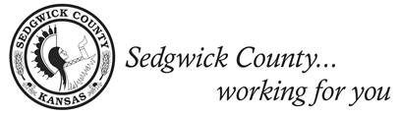

District 4 Citizens Advisory Board Meeting
“Let’s Talk Budgets”
Agenda

Monday, May 9th, 2022 Park City – City Hall
6 p.m. 1941 East 61st St N, Park City

Board Members: Adam Bosworth, Jamie Buster, Ronald L. Colbert Sr., Zach Day, Nalini Fraser, Philip Fraser, Maria Elena Gonzalez, Deb Gruver, Nichole Lee, Mark Masterson, Rebecca Osborn, Robert Simon

County Representatives and Speakers: Commissioner Lacey Cruse, Lindsay Poe Rousseau, Park City Finance Department

- Call to Order – Jamie Buster, CAB 4 Chair

- Meeting Minutes from April 11, 2022 - Citizens Advisory Board

- Welcome – Commissioner Lacey Cruse, District 4

- Sedgwick County Budget – Lindsay Poe Rousseau, Chief Financial Officer

- Park City Finance Department – Park City Finance Department

- Interactive portion

- Other

Next Meeting
- June 13, 2022 - Valley Center (“Let’s Talk Budgets”)

