District 5 CAB Oaklawn Sunview Senior Center, 2907 E. Oaklawn Dr.
August 5, 2022 Meeting Minutes
Board Members in Attendance: David Sowden – President, Fred Pinaire – Vice President, Liz Loera – Secretary, John Nicholas, Brad Smith, Janet Theoharis, Joseph Elmore, Christopher Wyant
County Representatives: Commissioner Howell
Speakers: Corinthian Kelly PPMC/Recovery Connect
- Call to Order:
  - David Sowden called the meeting to order at 4:00 pm
- Invocation:
  - Fred Pinaire
- Flag Salute:
  - All members stood for pledge of allegiance
- Roll Call:
  - David Sowden, Fred Pinaire, Liz Loera, John Nicholas, Brad Smith, Janet Theoharis, Joseph Elmore, Christopher Wyant
  - Quorum was present
- Approval of Minutes:
  - David Sowden moved to approve the June 3rd, 2022 meeting minutes. Liz Loera seconded the motion. The motion passed unanimously
- Public Agenda:
  - Michael Wholheiss, Discussed theft in district, recommending caution
  - Joseph Elmore, discussed accusation of agism with DCFS in adoption of granddaughter
  - Janet Theoharis, discussed long wait (90 minutes) in election lines in the heat on August 2nd 2022.
- New Business:
  - Recovery Connect Presented by Corinthian Kelly WSU PPMC
    - Recovery connect is SC economic recovery program run by the PPMC at WSU, to connect individuals, businesses, and non-profits to help them recover from the pandemic through ARPA funding.
      - The goal is to provide awareness about existing resources through the recovery connect website, community outreach, events, and social media.
      - Awareness will provide access to community members in need.
      - The PPMC with provide support, assistance, education, and grant writing workshops to community members.
    - Participant process includes (1)Participant inquiry, (2)Initial assessment with resource specialist, (3)Identify resources and make referrals, (4)Receive assistance from resource partners, and (5)Participant follow-up survey.

    - Community Partners include:
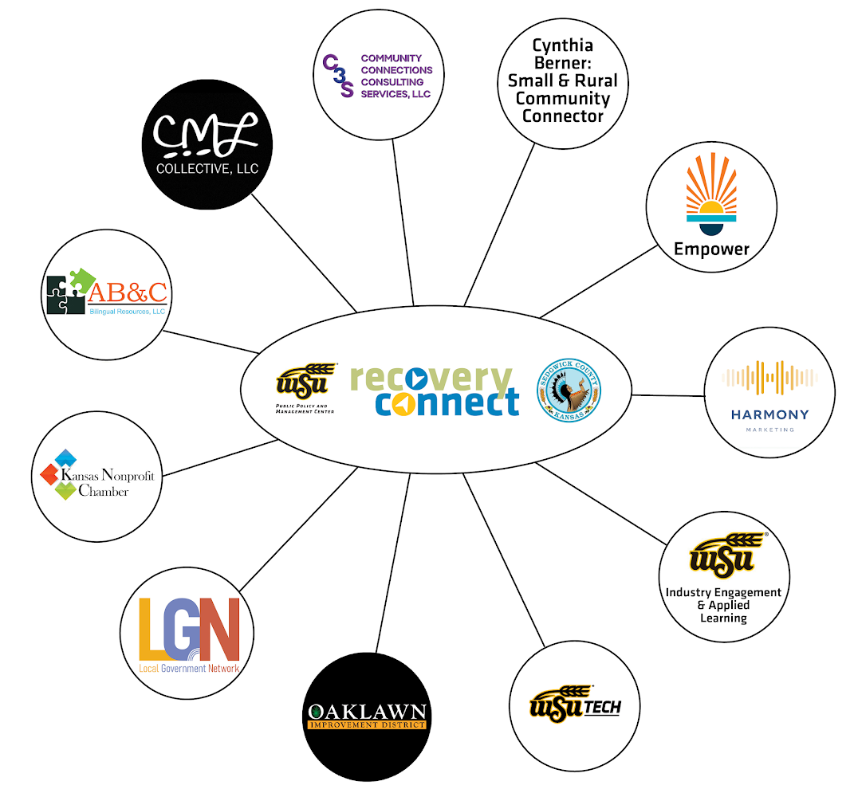
    - The PPMC is asking D5 CAB to help spread the word and help determine, what the greatest area of needs are in district 5? What types of resources can help? What groups would benefit from Recovery Connect presentation? How can the PPMC make the program more successful?
    - Website: www.Recovery-Connect.org
    - Contact: recoveryconnect@wichita.edu
(316) 978-6737
@SCCovidRecovery

- Commissioners Report
  - Sedgwick County Budget
    - Budget hearing on August 3rd, 2022 there was a request for spending on seniors centers, specifically for an aging mill levy. Request for funding increase in the extension office. Request for making Juneteenth a recognized holiday. No public support asking the commission to cut the budget or reduce spending.
  - Assessed property value for Sedgwick County increased 9% as of 1/1/22. Using last year’s mill levy of 29.359 plus a technical of adjustment of 0.011. This increase coupled with 14% inflation will negatively affect the public.
  - Sheriff’s Office - down 114 FTE capacity is 220 positions (less than 50% staffed)
    - The only people applying are 18 year olds
    - No lateral pay to attract talent from other police departments.
    - Staff are working 80’s per week making $100,000/year with overtime.
    - Recent incident involving a deputy and inmates smuggling contraband diminishes effectiveness of the county jail.
    - The Sheriff’s Office receives roughly $66 million of about 50% of the annual budget.
  - Fire Department – down 35 firefighters since 2015, calls have increased 40% since 2015
    - Cities inside the fire district pay into the fire mill levy, cities outside the fire district don’t pay, yet receive fire services.
    - Current financial status of fire district, fire staff are asking for raises, small cities like Maize are considering pulling out of county fire services. This could cause insolvency in the county fire district.
  - Structurally the budget is unsound, Sedgwick County will fall into deficit spending, unless a tax increase is approved.
  - Aging Mill Levy – mill levy increased but dollar amount stayed the same, despite large spike in aging population. Commissioner Howell request CAB members help create a ballot question with more precise definition in collection and distribution of aging funds.
- Election integrity:
  - Signature matching required for ballot and envelope
  - Voter ID required
  - Printer/Copier/Scanning security measure built into envelope
  - Color combination of red/black/grey are security feature limiting copying/scanning
  - Size of ballot, numbered edges are additional security measures for ballots
  - Black marks on 8 ½ X 17 sheet of paper are calibration marks to verify authenticity
  - Drop box under 24/7 surveillance, small slot for ballots, picked up daily by bipartisan team requiring 2 keys
  - Ballot request requires driver license number, DOB, voter signature, address
  - John Nicholas - 91% of ballots in this election were collected through the mail, the post office is the not secure in creating election integrity.
  - Computers are on local area intranet
  - Tabulators will flag machine if voting doesn’t match voters political party (under/over vote)
  - Public can tour and test voting sites with the elections commissioners.
  - Election help is still needed from the public for the audit
- Traffic Study at 47th and K-15
  - District 5 needs to voice need to have a study administered to resolve the problem of this dangerous intersection

- Derby EMS
  - Derby is looking at creating their own EMS in part due to the heart attack incident as the Derby City Council meeting
  - Commissioner Howell calls on CAB to get the correct information out regarding EMS response time
- 2022 Budget Hearing
  - Chairman Sowden request CAB become more informed and play a larger role in education themselves and the public on budget concerns
- Board items for next meeting
  - David Sowden suggested having Commissioner Howell and opposing candidate speak to D5 CAB
  - Develop senior funding budget request to present to the BOCC
  - Develop a time slot for items to address in next meeting
- Adjournment:
  - Adjourn 6:12 pm
  - Next meeting held on September 2nd, 2022

