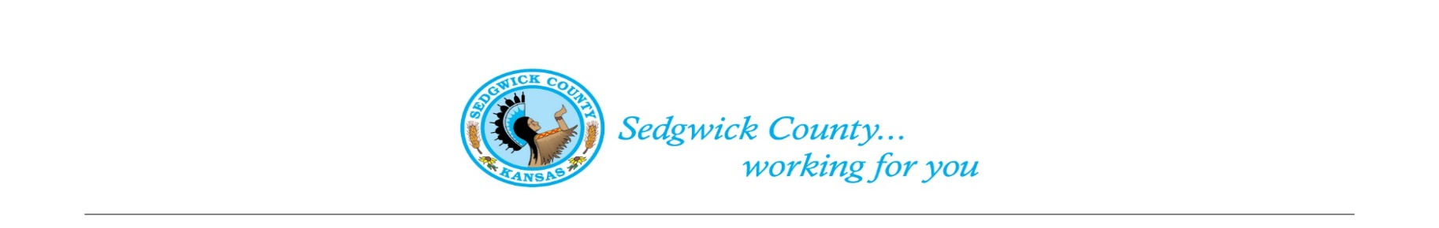
District 5 CAB Oaklawn Sunview Center, 2937 E Oaklawn Dr.
February 11, 2022 Meeting Minutes
Board Members in Attendance: David Sowden, Fred Pinaire, Liz Loera, Amanda Amerine, John Nicholas, Brad Smith, Joseph Elmore, Janet Theoharris
County Representatives: Commissioner Jim Howell
- Call to Order:
  - David Sowden called the meeting to order at 4:08 pm
- Invocation:
  - Brad Smith led the invocation
- Flag Salute:
- Roll Call:
  - David Sowden, Fred Pinaire, Liz Loera, Amanda Amerine, John Nicholas, Brad Smith, Joseph Elmore, Janet Theoharris
  - Quorum was present
- Approval of Minutes:
  - David Sowden moved to approve the January 2022 meeting minutes. Joseph Elmore seconded the motion. The motion passed unanimously.
- Public Agenda:
- New Business:
  - Commissioner’s Report
  - Chairman David Sowden recommends creation of traffic subcommittee to look at traffic issue.
  - Chairman David Sowden asked if board wanted to take opportunity to submit another statement and/or appear in front of the BoCC again in support of mobile mental health.
  - Agenda: Other Items - A look at what’s next
- Chairman David Sowden explains Wesley Hospital Article – Final stages of signing contract with private ambulance firm for hospital transfers
- Effects Sedg. Co. EMS to approx.. 9% of annual budget
- How do you increase pay/pay for education with a 9% reductions
- ARPA Fund-use for 17 million dollar Mental Health Facility
- No conversation about mobile mental health in conjunction
- Commissioner Jim Howell states down 200 people at COMCARE and looking at minimum at a 7% salary increase per year for the next 5 years to get back on feet which is about $40 million above what we are currently doing in additional salary
- COMCARE 2 factions
- Community Moving towards San Antonio Campus Model
- 50 beds in Sedgwick Co. is getting more some attention from State
  - County Ethics Policy: Sedgwick County does not have one, Johnson and Wyandotte Counties do have an ethics policy
- Idea of governmental transparency – see voting records, etc.
- Resource to look up information – current system very cumbersome
  - Follow-up with 47th street
    - Study to build a bridge to bypass the train on K-15 & 95th. Study done and possibility of having a $20-25 million bridge might be something group wants to look at.

- Adjournment

