

ADDENDUM #2
RFP #26-0011
ELECTRONIC WAIT LINE MANAGEMENT SYSTEM

July 31, 2026

The following is to ensure that vendors have complete information regarding this Request for Proposal. Here are some clarifications regarding the electronic wait line management system:

Questions and/or statements of clarification are in bold font, and answers to specific questions are italicized.

At this time, the county has decided to pull this proposal and reject all responses.
A revised RFP will be issued in the future.

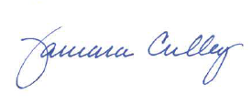
Tammy Culley
Purchasing Agent

TC/ch

