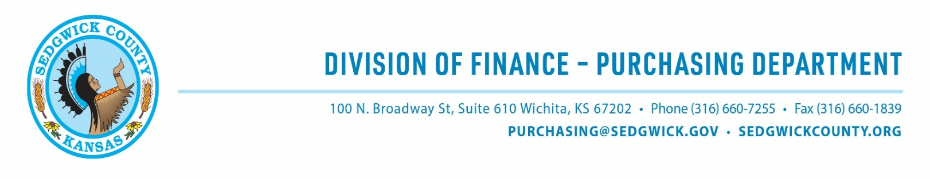
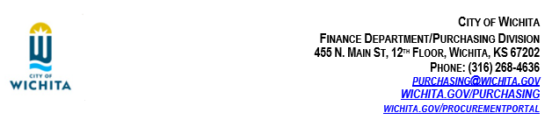
ADDENDUM #1
RFP #26-0082
OVERDOSE PREVENTION INITIATIVES
Opioid Settlement Fund | Estimated Allocation $270,000 (up to $75,000 per award, 3-4 anticipated awards)
Sedgwick County, Kansas, in coordination with the City of Wichita, has prepared this addendum to ensure applicants have complete information before submitting a proposal. Below are the questions received on this RFP through August 13, 2026, and responses approved by the County and City posted on August 21, 2026.

General Questions (apply to all four Opioid Settlement Fund RFPs — 26-0080, 26-0081, 26-0082, 26-0083)
- Can an organization apply for more than one of the four Opioid Settlement Fund RFPs?
Yes. Applicants may apply to more than one funding strategy. Submit a separate Response Form and required attachments for each RFP (RFP Section II, Background; Response Form, Common Questions #1: “Can we apply for more than one strategy? Yes. You may apply to one (1) or more of the four (4) strategies. Submit the materials required for each.”)
- How many proposals can one organization submit for a single RFP - for example, separate proposals to serve different populations (such as adults and adolescents)?
An organization may submit more than one proposal for the same RFP if each proposal represents a genuinely different program (for example, one program for adults and a separate program for adolescents). Keep in mind that the number of anticipated awards for each strategy is limited, so multiple proposals under the same RFP will be competing against each other, in addition to other applicants, for that same limited pool. As a reminder, a single proposal can also serve more than one population: Response Form Section 4.2 lets you check more than one population served, and Section 4.3 asks which group you will serve first.
- Are letters of support required or permitted?
They are optional, not required.
- Is there a place where an organization interested in serving as a subawardee, collaborator, or vendor (rather than lead applicant) can list its products or services for lead applicants to find?
No. Neither the RFP nor the Response Form includes a subawardee or vendor directory or matching mechanism. Organizations interested in a supporting role would need to reach out directly to prospective lead applicants.

- What email address should proposals and questions be sent to? (The RFP document itself lists a City of Wichita address.)
Purchasing@sedgwick.gov. RFP Section III, Submittals: “For all submittals, the RFP number must be entered in the subject line and email the entire document with supplementary materials to: Purchasing@sedgwick.gov.” Any publication on the City of Wichita's Procurement Portal is for marketing purposes only; inquiries submitted there are forwarded to the County.
- Was the August 3 pre-bid webinar recorded, and are slides or notes available?
https://youtu.be/3WCVFmIoY0M

- Is there a preference for in-state (Kansas) applicants compared to national organizations with local partnerships?
No formal preference is stated. Target audiences must be residents of the County or City.
- There seems to be a contradiction: is data and evaluation required, or not?
A formal evaluation is not required, but reporting on performance metrics is required. Response Form Section 7 asks applicants to choose the outcome measures they will report, and it is scored (10 of 100 points, “Performance measures”). If funded, RFP Section VIII and the Response Form both require quarterly performance reporting for the life of the contract. What's flexible is which specific measures you choose from Section 7.1's menu — not whether you report at all.
- For fringe benefits in the budget, is an overall fringe cost per position sufficient, or does each component need to be broken out?
Each component needs to be broken out, with its rate and dollar amount. Budget Workbook instructions, Category B: “Break out each fringe component (FICA, workers’ comp, health, retirement) with its rate and dollar amount.”
- Is the one-year renewal option a no-cost extension, or would it include additional funding?
No additional funding will be provided. The one (1)n year renewal, if exercised, will be treated as a no-cost extension of the existing award under the same terms and conditions (RFP Section VI.D: the contract “shall continue until December 31, 2027, with one (1) year option to renew under the same terms and conditions... at the sole discretion of County and City”).

Overdose Prevention Initiatives – Specific Questions (RFP #26-0082)
- If a nonprofit applicant is not currently in good standing with the Kansas Secretary of State, may it apply through a fiscal sponsor or fiscal agent that is in good standing? If so, should the fiscal sponsor be the applicant of record, what documentation is required, and does “good standing” mean Secretary of State status, IRS 501(c)(3) status, or both?
Consistent with the business entity standard treatment act (K.S.A. 17-7901 et seq.), both foreign and domestic corporations (inclusive of nonprofit corporations) are required to register with the secretary of state when doing business in the State of Kansas. As noted in Section 14 of the Request for Proposal Conditions, if you are a Domestic (Kansas) nonprofit corporation, you will need to furnish evidence of good standing in the form of a Certificate signed by the Kansas Secretary of State. If you are a Foreign (non-Kansas) corporation, you will need to furnish evidence of authority to transact business in Kansas, in the form of a Certificate signed by the Kansas Secretary of State; and 2) a copy of the Corporation Resolution evidencing the authority to sign the Contract Documents, executed by the Corporation's Secretary or Assistant Secretary. The term “Certificate” means “Certificate of Good Standing” that is issued by the Kansas Secretary of State. Please note that proof of good standing is required prior to the award being issued, not at the time of the application. At this time, we do not accept applications through fiscal sponsors.

- Is a combined proposal addressing both Goal 1 and Goal 2 encouraged, and would it be reviewed and scored as a single integrated project?
Yes. The RFP states applicants “should clearly identify which goal(s) their proposed program addresses and design their narrative, activities, and outcomes accordingly,” and Response Form Section 5.1 lets an applicant check more than one of the strategy's goals. A combined proposal is submitted as one Response Form and reviewed as one project under the standard 100-point rubric — there is no separate or split scoring for combined-goal proposals.
- For Goal 2, does the naloxone leave-behind component require distribution only through first responders or can qualified entities also distribute kits and provide overdose response training directly through youth-serving organizations, schools, family sessions, and community events?
Distribution isn't limited to first-responder channels. The RFP's example eligible activities for Goal 2 include both “procure and distribute naloxone kits for first responder leave-behind programs” and “deliver community-based naloxone distribution and overdose education programs” (RFP Section IV, Goal 2).
- Are there specific training, certification, or standing order requirements for staff who will distribute naloxone under this funding?
The RFP lists “train first responders on naloxone administration and leave-behind protocols” as an example eligible activity but does not specify a required certification, standing order, or training curriculum for non-first-responder staff distributing naloxone.
- For Goal 1, are curriculum licensing fees, facilitator training, and related materials considered allowable costs within the $75,000 total award?
This is likely allowable, yes. The Budget Workbook lists “evidence-based curriculum materials” as an allowable Supplies cost (Category E), and facilitator training or staff time would fall under Personnel, Contracted Services, or Travel depending on how it's delivered.
- Is there a minimum age or other guidance for youth who may receive overdose prevention education, and are there preferred reporting metrics when combining youth resilience outcomes with naloxone distribution outcomes?
Response Form Section 4.2 defines “Youth” as ages 13–24 as one of its population checkboxes, with “Children (under 13)” as a separate category; the RFP does not set an additional minimum age.

Firms interested in submitting a proposal must respond with complete information and deliver on or before 1:45 pm CDT, September 15, 2026. Late responses will not be accepted and will not receive consideration for final award.

Sincerely,
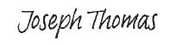
Joseph Thomas,
NIGP-CPP, CPSM, CPSD, C.P.M. Purchasing Director

JT/ch

