

ADDENDUM #1
RFP #26-0050
ARMORED CAR SERVICES

September 30, 2026

The following is to ensure that vendors have complete information prior to submitting a Request for Proposal. Here are some clarifications regarding the Armored Car Service:

At this time, the county has decided to pull this proposal and reject all responses.

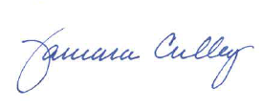

Tammy Culley
Purchasing Agent

TC / ch

